PHYSICS HANDBOOK

for

AS/A2 LEVEL
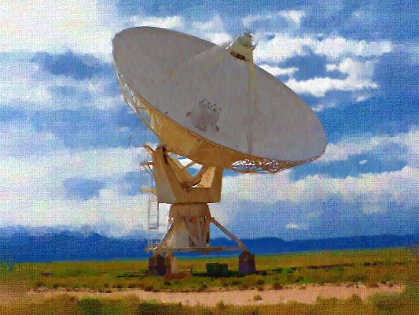
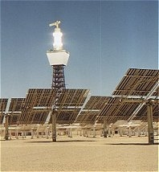
North Chadderton School
Interactive versions of this Handbook are online
at www.e-teach.org/physics www.webucate.org
www.webucation.org www.goscience.org
Contents
Page

1. Welcome 3

- What is Physics?
- Why study Physics?
- Physics and the 21st Century

2. Studying Physics at North Chadderton School 5

- Aims of the course
- Entry requirements
- Companion subjects
- Careers/Higher Education Opportunities
- Expectations and Challenges

3. Resources for Learning 9

- AQA Physics textbook
- Calculations for A-level Physics Textbook
- Support Materials/Revision Guides
- E-Learning
- Enhancing your knowledge and understanding

4. What will I be doing in Year 12? 12

- Unit 1 : Particles, Quantum Physics and Electricity
- Unit 2 : Mechanics, Materials and Waves
- Unit 3 : Investigative and Practical Skills

5. What will I be doing in Year 13? 14

(a) Unit 4 : Particles, Quantum Physics and Electricity
- Unit 5 : Mechanics, Materials and Waves
- Unit 6 : Investigative and Practical Skills

Appendices 16

- How Science Works
- Physics Student Proforma
- Enhancing and enriching your learning
- Glossary of Terms used in Examination Questions
- Mathematical requirements for AQA AS/A2 Physics A
- Data and formulae
- Glossary of terms related to measurements
- SI base units
- Derived units
- Prefixes and the Greek Alphabet

1. Welcome to AS Physics

We are delighted you have chosen to study physics at AS level.
We hope that you will benefit from this course and gain a greater understanding of why and how Physics is so important in the modern world.

(a) What is Physics?

Physics is the study of matter and energy and how they interact with each other. Physics goes from a grand scale, aka the Universe, to the very smallest parts of the building blocks of everything: atoms, and then even smaller than that….to look at the particles that build up the nucleus.

(b) Why study Physics?

Physics is interwoven into virtually every aspect of our lives. Every electrical device you use, including mobile phones, depends upon basic physics concepts and principles. Every mechanical device, including cars, also relies on applications of physics. Your body has also developed sense organs that take into account and adapt to the behaviour of sound, light, heat, electrical and mechanical systems. You are a biological machine adapted to be successful in a world where physical principles permeate everywhere.

Physics can give you a greater understanding of strange behaviours! These happen both on a very small scale and also on very large scales: particles that sometimes behave as if they were waves, particles that seem to tunnel through matter, some that cannot be seen, black holes, wormholes, quarks and strangeness numbers!

At the other extreme, you will look at the largest possible scale: the Universe, and find out there are some very strange behaviour indeed, which cannot be explained by laws that our famous Physicist Isaac Newton discovered. Yet, these laws were good enough to be used in sending the first men to the Moon!

Physics is not set in stone…fixed and for all time. It, like other science, is constantly evolving and new theories, discoveries, and ways of thinking gradually take the place of previous knowledge and understanding.
You can be part of this new age of discovery.

Isaac Newton was able to encapsulate the fun and excitement of studying Physics, and the excitement of new discoveries…

“I do not know what I may appear to the world, but to myself I seem to have been only like a boy playing on the sea-shore, and diverting myself in now and then finding a smoother pebble or a prettier shell than ordinary, whilst the great ocean of truth lay all undiscovered before me”

You will discover things that you never knew before, and learn about relatively new discoveries that have changed our ways of thinking.

(c) Physics and the 21st Century?

Underpinning your studies in physics is a set of concepts known as “How Science Works” . The more you study physics, the greater understanding and appreciation of how science is interwoven into virtually every aspect of our lives, at a local, national , and international level.

Everything using energy is based on knowledge, understanding and application of physics. Science, technology and society are all linked, and our use of science depends on decisions. For example, we often need to make decisions about the benefits of a certain technology against the risks. Some solutions to problems depend on a range of factors. Choices have to be made by comparing the advantages and disadvantages of different ways of generating electricity. A solution on generating electricity on a remote island in Scotland might be quite different than generation electricity on an island in Greece. Local resources need to be taken into account, to provide the best solution, together with cultural, economic and social issues.

Another example is the use of mobile phones and whether they provide a health issue to users. Some studies have shown there is a danger, and other evidence suggests that there is no causal link between their use and brain tumours. Many devices used today carry a degree of risk associated with them. The ALARA (as low as risk as reasonably achievable) is often applied when using devices such as mobile phones.

More details of “How Science Works” is given in Appendix1

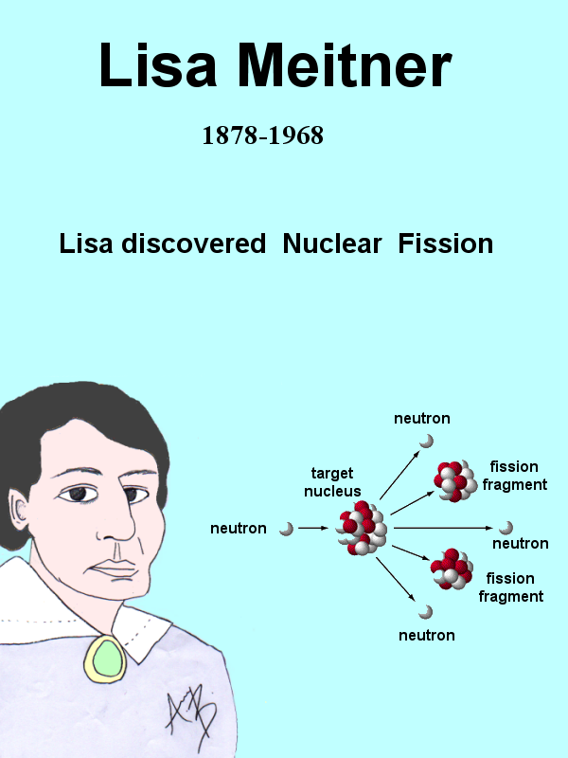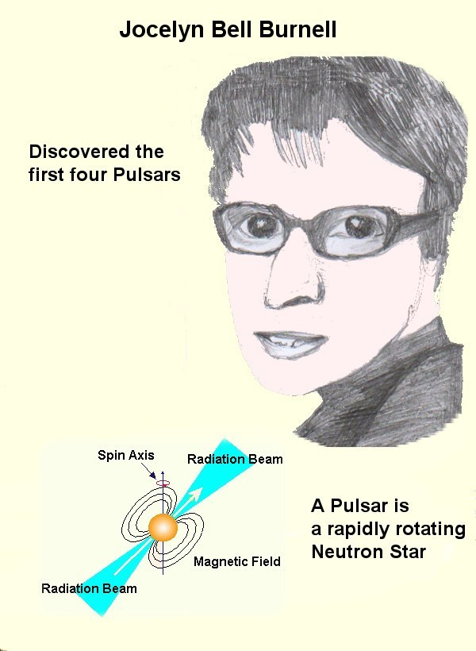
2. Studying A-level Physics at North Chadderton School

(a) Aim of the Course

You might think that the aim of the course is to learn about physics.
To a large extent this is true. However, the course provides you with opportunities to develop skills that will enable you to succeed in any future studies, in careers, and being part of a global community:

1. Understanding the nature and limitations of scientific knowledge
This will include hypothesis and prediction, links between data and explanation, modelling, and the role of the scientific community in validating new knowledge;

2. Developing scientific enquiry skills
Experimental skills, data handling and assessing the quality of data;

3. Developing Skills in Communication
This involved the use of scientific language, mathematical skills and presentation of data

4. Applications and implications of science.
You will consider technological decision making in the context of benefit versus risk and ethics.

These areas are commonly referred to as How Science Works (Appendix 1) . However, many of the skills are not just relevant to science, they can be applied to other subjects, and to most aspects of your life. Above all, want you to enjoy studying physics, and gain success to enable you to succeed in any further studies or career path you might choose.

(b) Course Entry Requirements
- Grade A* - C at GCSE science (core and additional)
- Grade C GCSE mathematics
Exceptions to these requirements may be only be considered in extenuating circumstances at the discretion of the department.

(c) Companion Subjects

There are no fixed requirements for studying other subjects alongside Physics.
Maths AS would be useful, but not essential. Most students study at least another science, if they are intending to pursue a career or further educational course at University or College. Other students who are thinking of becoming an engineer or architect have combined physics with design technology and/or art.

However, if you are interested in Physics and enjoy studying science, then welcome aboard!

(d) Careers/Higher Educational Opportunities

Studying physics open up a range of opportunities in further education and in career paths. It is regarded as a stepping stone to further educational courses in science and engineering. Its mathematical content usually make it highly regarded by most university admissions officers. The range of opportunities is not limited to science. Many business and law courses, for example, will accept physics and an entry qualification.
Apart from careers in pure and applied science, including engineering, there are other interesting careers on offer in the modern world that you might not have even considered! Here are some listed at www.physics.org
For Career Paths you can peruse the many opportunities in the following fields at http://brightrecruits.com/ :
Mechanical engineer Ice Scientist Laser Fusion Scientist Solicitor Science Communicator Astrophysicist TV Producer Sound Engineer Renewable Energy Manager
Astronomy and Space Manufacturing and industry
Electronics and Semiconductors Nanotechnology
Energy and Renewables Nuclear and Fusion Technology
Computer Modelling Optics and Photonics
Defence and Aerospace Software Development
Environmental and Earth science

(e) Expectations and Challenges

Priorities for Action…and Success

Studying at A-level requires both commitment and time. You will have 5 hours of Physics per week and will be expected to put in at least as much time again outside lessons.

Your priorities will be :

1. Completing assignments 2. Meeting deadlines 3. Reviewing your work/notes

You will be expected to meet deadlines for all homework assignments. If you experience any difficulties in completion of your work. It is essential that you contact the teacher before the deadline.

From the very first day, in the first lesson, you will need to make sure you understand the work your have done. If you have any questions, then annotate your notes, and make sure you ask your teacher for assistance and further guidance.
Passive reading though notes is not a constructive way of revising and consolidating knowledge and understanding.

Highlight the main key points
These were given in the learning objectives for the lesson.

Practice calculations!

Remember, physics A-level requires you to be highly proficient at applying Maths to problem solving. Your teacher will provide you with homework and ample opportunities to develop your mathematical skills. You will need a scientific calculator for your work.

Ask for assistance

Your teacher will be able to assist you with any areas of work that you need assistance with, including maths.

When you have completed your work for the lesson it is essential that you go over this work on the same day to consolidate your knowledge and understanding , and to expand certain points if necessary. Contact your teacher(s) if you need any further help and guidance. Whatever strategies, don’t ever leave questions until the week before the exam!

Keeping Records of your Work
We ask you to be organised, and keep everything in a place where you can easily find your work and notes easily. Since we live in the 21st century, not everything is now done on paper. There will be times when you are required to do work on paper (still very common!), and times when an electronic activity is the only option/requirement.

So, in most cases, you will need a hybrid system of organising your work……..

(a) Paper-based storage system

This is a traditional way of storing notes/information. Very heavily dependent on your organisational skills, and still required in many aspects of your studies at A-level, such as practical work, and individual note-taking

Have two files for the subject :

You should have a ring binder to store all your current notes. This is convenient since the specification breaks down into well-defined sections. After the completion of each section, transfer the notes into the second ring binder. Label the dividers with the different sections of the physics specification.

(b) Electronic Storage system(s)
You can use a laptop/desktop to store the notes/work you produce in class

1. Make a folder such as Physics AS,
2. Make subfolders for each Unit you study (Unit 1, Unit2, etc. )
3. Make any further subfolders in the Unit folder for different sections
(Particle, Quantum Physics, etc..)

Using this method you do not have to do any transfer any notes, since they will be automatically in the right folder.

Essential: Backup your work on a weekly basis. This can be done by using a USB stick, or external hard drive. You will also be provided with a storage area online where you can upload your notes/work. In this way, you will always have a backup set of notes if your laptop develops a problem, or goes missing.

E-Learning: If you complete activities online on Moodle or Kerboodle, you work will be stored automatically. You also have the option to print out your work. In some activities you are required to download the assignment, complete it, and then upload it for marking.
Feedback/marking on assignments will provided online

You will also be provided with the opportunity to upload your personal notes onto your own e-learning area on Moodle. This provides an additional means of storing your work.

You can download any aspect of your work on a 24/7 basis.

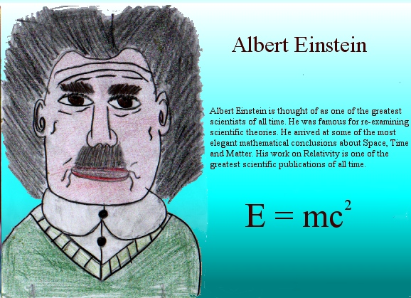

3. Resources for Learning
(a) AQA Physics Textbook
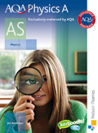
Author(s): J Breithaupt
Published by Nelson Thornes ISBN 978-0-7487-8282-6

Key features:

- How Science Works; with links from the textbooks to make difficult concepts easier to understand.
- Practical experiments; to develop the investigatory skills needed for ISA exams
- Maths Skills; with worked examples written by examiners clearly demonstrating how to do the calculations.
- Clearly stated Learning Objectives to let you know exactly what they’ll need to learn and understand in that topic.
- Essential examiner advice highlighting common errors as well as top tips on exam preparation help you to understand the examiner's expectations.

(b) Calculations for A-level Physics

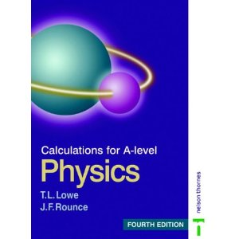

You absolutely have to get to grips with Maths in this course! This book will help you to reach the highest grades. We provide you with this support book, which we will use to ensure that you have plenty of practice at developing and applying mathematical skills to solving problems in physics.
Appendix 5 gives the the mathematical requirements for this course.
(c) Support Materials/Revision Guides

You will be provided with a range of support materials for your course, and revision materials to help you to be fully prepared for the examinations.
Many of these resources will be available for downloading from our website at www.e-teach.org/physics and some will be provided on our own DVD/CDs
(d) E-learning Support/Activities

E-learning is not intended to replace teaching! It is designed to complement, enrich and enhance your learning.

You will need to have access to the internet. We will be using two Virtual Learning Environments (VLE’s) during the course. Some of your activities will be done using online activities and assignments.

Some assignments will be done in lessons, using laptops, and other requires you to complete work outside of scheduled lessons. Some homework assignments will be set using the VLE’s.

VLE’s offer superb opportunities to develop your knowledge and understanding of the subject. Here are some of the features of Virtual Learning Environments:

Animations | Simulations | Exam Practice
Web Quests | Case Studies | Presentations
Analysis Tools | Teacher Notes | Interactive Learning
Videos | Revision Guides | Discussion Tools

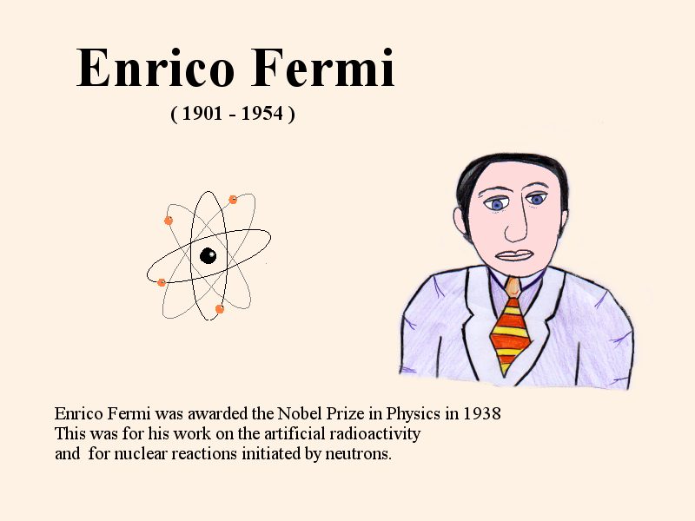

We offer two e-learning environments………….
- Moodle : http://www.e-teach.org/physics

Moodle is an Open Source Course Management System which is now used by over 60,000 educational establishments, around the world, from Universities to Primary Schools. North Chadderton School was one of the first schools to download and use Moodle for A-level Students.

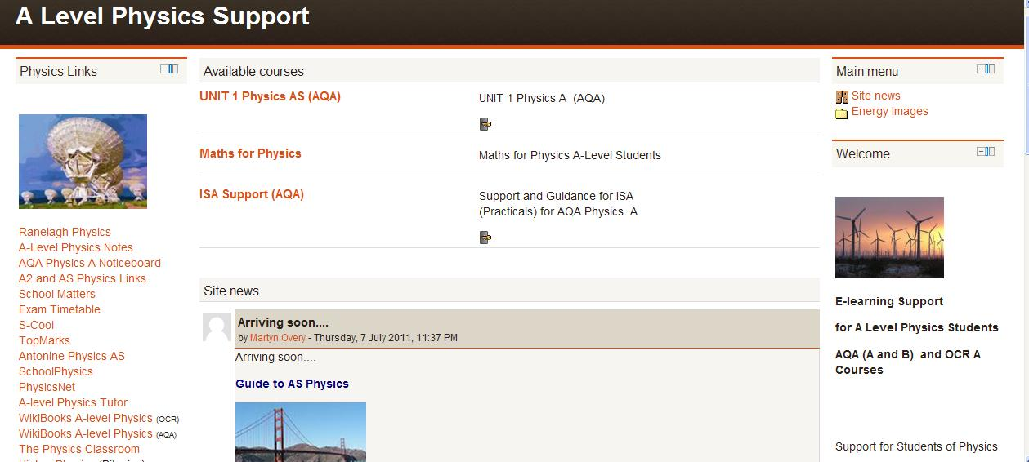

This is designed specifically for your course at North Chadderton School.
You will have your own login and password, and your own online area, where you can download resources and assignments, watch presentations, complete revision/tests, and upload your work. Lesson notes and revision materials, exam papers will be available.

You can find more about Moodle at http://moodle.org/about/

and a demonstration website is at http://demo.moodle.net/

(ii) Kerboodle



This is an online learning facility provided by Nelson Thornes, to assist teachers in teaching and students in learning. You will be provided with a username and password to enter Kerboodle.

You can find out more about Kerboodle at

http://support.kerboodle.com/

(e) Enhancing your learning and understanding

Once upon a time, students were told to ‘read around the subject’ by teachers.
This was not a very helpful term, and rather vague to say the least.. Yet, you really do need to keep track of developments in physics, and how physics appears in the modern world. Principal Examiners often set questions related to events in the news, and this can be related to local, national or international issues. So don’t expect to find everything in an exam paper from the content in standard textbooks!

A list of very useful resources for keeping up to date with the latest developments is given in Appendix 3

4. What will I be doing in Year 12?
The AS specification has 3 Units of Study:

Unit 1: Particles, Quantum Physics and Electricity
This unit involves two contrasting topics in physics: particle physics and electricity. Through the study of these topics, you should gain awareness the on-going development of new ideas in physics and of the application of in-depth knowledge of well-established topics as electricity.

Particle physics

You will study the fundamental properties and nature of matter, radiation and quantum phenomena.

Electricity

In this module we will build on and develops previous work at GCSE studies.
It provides opportunities for practical work and looks into important applications of electricity in the modern world
Unit 1 – PHYA1 Particles, quantum phenomena and electricity
Written Examination – (70 marks/120 UMS), Time : 1¼ hours
Consisting of 6 or 7 structured questions
This will be worth 40% of the total AS marks and 20% of the total A Level marks
The assessment will normally be in JANUARY

Unit 2: Mechanics, Materials and Waves
This AS module is about the principles and applications of mechanics, materials and waves.
Mechanics
In this section you will be introduced to vectors and then develop your knowledge and understanding of forces and energy from GCSE Additional Science.
Materials

In this section you will study the properties and applications of materials in terms of their bulk properties and tensile strength.
Waves

This section extends GCSE studies on waves by developing your in-depth knowledge of the characteristics, properties and applications of waves, including refraction
Assessment :
Unit 2 – PHYA2 Mechanics, materials and waves
Written Examination – (70 marks/120 UMS),
Consisting of 6 or 7 structured questions

This will be worth 40% of the total AS marks, and 20% of the total A Level marks
The assessment will normally be in JUNE

Unit 3: Investigative and Practical Skills

Throughout the course you will carry out experimental and investigative activities in order to develop your practical skills. The experimental and investigative activities will be set in contest with the Units of Study.

You will be assessed on your practical skills using two methods:

• Practical Skills Assessment (PSA)
• Investigative Skills Assignment (ISA).
The PSA will be based around a school assessment throughout the AS course on your ability to follow and undertake certain standard practical activities.

The ISA will require you to undertake practical work, collect and process data and use it to answer
questions in a written test (ISA test).

During the course you will gain experience in the use and application the following equipment:
Electric meters (analogue or digital), metre rule, set squares, protractors, vernier callipers, micrometer screw gauge (zero errors), an electronic balance, stopclock or stopwatch, thermometer (digital or liquid-in-glass), Newton meters.

Throughout AS Physics you will be given opportunities to:
• demonstrate and describe ethical, safe and skilful practical techniques
• process and select appropriate qualitative and quantitative methods
• make, record and communicate reliable and valid observations
• make measurements with appropriate precision and accuracy
• analyse, interpret, explain and evaluate the methodology, results and impact of your own and others experimental and investigative activities in a variety of ways
5. What will I be doing in Year 13 ?

The A2 specification has 3 units

Unit 4: Fields and Further Mechanics
This follows on from the work studied in AS Physics. The first section advances the study of momentum and introduces circular and oscillatory motion and covers gravitation. Electric and magnetic fields are then covered, together with basic electromagnetic induction. Electric fields lead into capacitors and how quickly they charge and discharge through a resistor.

This exam will be taken in the JANUARY of Year 13

Unit 5: Nuclear Physics, Thermal Physics + Optional Topic
This unit consists of two sections
Section A : Nuclear and Thermal Physics
This looks at the characteristics of the nucleus, the properties of unstable nuclei and how energy is obtained from the nucleus. Then we study the thermal properties of materials, and the properties and nature of gases.
Section B : Optional Topic
You will be given an opportunity to study one of the following topics, which will give a deeper understanding and awareness of a selected branch of physics
A Astronomy and Cosmology B Medical Physics
C Applied Physics D Turning Points in Physics

This exam will be taken in the JUNE of Year 13

Unit 6: Practical and Investigative Skills

This is similar to Unit 3.
The only difference is that the investigations will be in context with the topics studies in Units 4 and 5.

You will be assessed on your practical skills using two methods:

• Practical Skills Assessment (PSA)
• Investigative Skills Assignment (ISA).



PHYSICS HANDBOOK

for

AS/A2 LEVEL


Explore the Universe with us…
in the 21st Century

APPENDICES

Appendix 1: How Science Works
How Science Works is an underpinning set of concepts and is the means whereby you come to understand how scientists investigate scientific phenomena in their attempts to explain the world about us.
How Science Works recognises the contribution scientists have made to their own disciplines and to the wider world. It recognises that scientists may be influenced by their own beliefs and that these can affect the way in which they approach their work.
Also, it acknowledges that scientists can and must contribute to debates about the uses to which their work is put and how their work influences decision-making in society.
It can also be used to promote and develop your skills in solving scientific problems by developing an understanding of:
• the concepts, principles and theories that form the subject content
• the procedures associated with the valid testing of ideas and, in particular, the collection, interpretation and validation of evidence
• the role of the scientific community in validating evidence and also in resolving conflicting evidence.
As you become proficient in these aspects of How Science Works, they can also engage with the place and contribution of science in the wider world. In particular, students will begin to recognise:
• the contribution that scientists, as scientists, can make to decision-making and the formulation of policy

• the need for regulation of scientific enquiry and how this can be achieved

• how scientists can contribute legitimately in debates about those claims which are made in the name of science.

More details of How Science Works (HSW) are integrated into the study of Physics is given in the AQA Physics A Specification, which can be downloaded at:

http://store.aqa.org.uk/qual/gce/pdf/AQA-2450-W-SP.PDF


Appendix 2 : Please complete and give this to your Physics teacher(s)

A-Level Physics : Student Details


Name……………………………………………

Physics Group ……………….

E-Mail address (for E-learning) : ____________________________

ICT Access/Skills (tick)

I have access to a computer at home.

I have Broadband Internet access at home

ICT Skills: I have experience in using

A word processor A database Spreadsheet
PowerPoint or other presentation program

I have used online learning before
(such as SamLearning at KS3/KS4 or MyMaths)

GCSE Subjects and grades

Other Subjects studied in Year 12

Post –18 (options being considered)

Appendix 3 : Enhancing and enriching your learning

Physics Review
Don’t waste valuable time going through ordinary newspapers looking for physics articles! This is a superb resource. Leading examiners and subject specialists update you on the key topics they need to understand to achieve your potential at AS and A2. Regular columns develop core A-level skills and help students apply their understanding to how science works. There will be copies made available for you to borrow (see Dr.Overy) OR you can subscribe at a reduced student

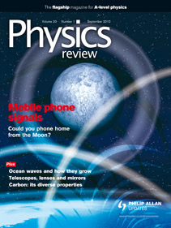

2. Internet Resources

Physics Newsfeeds

The latest Newsfeeds about Physics are sent directly to our A level Physics Support Website at: www.e-teach.org/physics

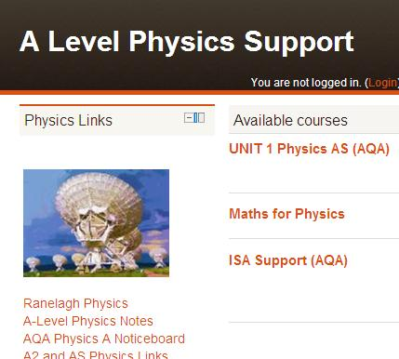

YouTube

There are some excellent YouTube videos for Physics

Someone has done all the hard work for you and listed them here:

http://physics.andreadecapoa.net/

You will also be given website addresses to relevant YouTube videos for all your Units of Study.
Physics A-Level Websites

These are general websites, but extremely useful for resources, for teaching and learning! Specific websites for each Unit will be provided during the course.

….Don’t forget our e-learning website at www.e-teach.org/physics

This website provides you with valuable additional links and resources

Ranelagh Physics
Absolutely brilliant resources for AQA A-level Physics.
Extremely useful for both teachers and students
http://ranelaghalevelphysics.wikispaces.com

A-Level Physics Notes
Useful notes on a wide range of Physics Topics
www.thestudentroom.co.uk/wiki/Category:A_Level_Physics_Revision_Notes
AQA Physics A Noticeboard
Download past papers + mark schemes

http://web.aqa.org.uk/qual/gce/science/physics_a_noticeboard.php
A2 and AS Physics Links
A database of links to most topics at A-level

http://www.asa2physics.co.uk/pages/

School Matters

Teaching and learning resources from University of Liverpool

http://schools.matter.org.uk/a-level.html
Exam Timetable

Find out when your exams will be set ….a reminder!

http://www.modernisationonline.org.uk/comptimetable/
S-Cool

Great revision website. Interactive activities.

http://www.s-cool.co.uk/a-level/physics
TopMarks

Another database of physics resources

http://www.topmarks.co.uk/Search.aspx?Subject=23&AgeGroup=6

Antonine Physics AS
Useful note and online tests, as you go through the notes.
Good revision website
http://www.antonine-education.co.uk/Physics%20A%20level/welcome_to_as_physics.htm

SchoolPhysics
Excellent animations + Teaching and revision resources

http://www.schoolphysics.co.uk
PhysicsNet

Useful revision /consolidation resources.

http://physicsnet.co.uk/a-level-physics-as-a2/
A-level Physics Tutor

Useful website, although layout/presentation needs improvement.
http://www.a-levelphysicstutor.com
WikiBooks A-level Physics (OCR)
Wiki website dedicated to OCR A-level Physics course
WikiBooks A-level Physics (AQA)

Wiki website dedicated to AQA A-level Physics
The Physics Classroom

Lots of multimedia resources + notes/revision materials
http://www.physicsclassroom.com/
Higher Physics

http://www.bbc.co.uk/scotland/learning/bitesize/higher/physics/
SamLearning

Interactive revision materials.
Our students obtain login information from our school

http://www.samlearning.com/

Animated Physics

http://www.animatedscience.co.uk/?cat=21

Java Applets (Animations)

Brilliant interactive resources for a wide range of topics

http://www.walter-fendt.de/ph14e/

Appendix 4 : Glossary of terms used in examination questions

You need to pay very careful attention to the wording questions. Principal examiners choose their words very carefully, so you must be aware of what they are looking for in an answer. In physics it is essential that you know definitions exactly. Waffle counts for nothing. You are strongly advised to keep a definitions booklet, as you go through the course, with all the definitions, laws, principles, and the correct units for physical quantities.

“State”

In Physics this usually applies to Units or a Law or Principle. Make sure you know the correct definition….A-level standard, not media news standards. For example, Newton’s Third Law of Motion is NOT ‘Action and reaction are equal and opposite’, but “If an object A is applied to an object B then object B applies an equal and opposite force to object A “

“List”
This needs a number of features or points only. No explanation is required

“Define / What is meant by…?”
“Define” means you must explain clearly what is meant by a particular word or term.
If you have been taught a specific definition then you should use this phrase.
“What is meant by …?” does not require such a formal definition (but it is not incorrect to give one).

“Outline”
This means that you should give a brief summary of the main points. Look at how many marks are available and how much space is given for clues to the detail you need to give!
Do not repeat the same point five times expecting to get five marks!

“Describe”
This usually involves a few sentences, normally recalling a procedure or method. If it asks you to describe a graph, you should describe the shape of the graph, picking out key points (e.g. “it begins to level out at …” or “it gets steeper at …”). Note that an explanation is not required, unless it states ‘describe and explain’

If you are asked to describe an experiment, then you should state clearly how you would carry it out.

“Describe how you …”
This does mean you, the AS Physics student. The examiner will be looking for evidence of scientific procedures, knowledge and understanding that you have acquired during the course. It expects you to say what you could do in a school laboratory situation or how you would apply your knowledge to a familiar or unfamiliar situation.

“Evaluate”
Not to be confused with ‘list’. You need to give explanations. Evaluation of the evidence for and against a particular point of view means that you must give an explanation of the points that you make. Often used with data analysis questions, where you would need to consider the evidence then make careful judgements based on the evidence provided.

“Explain”
This is a why question You need to give a reason or an interpretation – not a description!
It involves you using your science knowledge to explain a process or application of a concept to a familiar or unfamiliar situation. Explaining a graph is not describing the shape of the graph, it is telling the examiner why, in terms of physics, the graph is the shape that it is.

“Suggest”
You will not have been taught a specific answer to a question that starts “suggest”. What you are expected to do here is to draw upon the information given in the question and upon your general knowledge and understanding of physics concepts to come up with an answer. There may be more than one correct response to a “suggest” question.

“Give the evidence for…” / “Use examples from…”
Follow any instructions very carefully. Usually you will be expected to refer closely to information given in the question. You will not get full marks unless you do so.

“Plot / sketch”
These terms are used when you are drawing graphs.
Plot means that you must be accurate, using graph paper where appropriate.
Sketch means you need to show the general shape of the expected curve.
Always label the axes correctly. In some cases, you would be expected to give appropriate scales.

“Calculate”
This means get out your calculator, enter the appropriate numbers and come up with an answer. In Physics you must ensure that the data is in appropriate SI units before substitution. In all cases, show your working. This gives the examiner an opportunity to give you intermediate marks, if you do not have the correct answer and units.

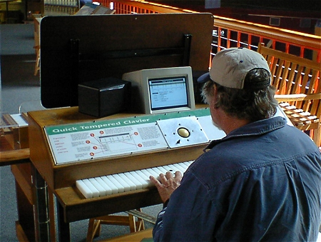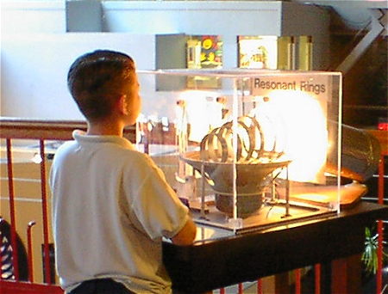

Appendix 5 : Mathematical Requirements

In order to develop your skills, knowledge and understanding in science, you will need to have been taught and to have acquired competence in the appropriate areas of mathematics relevant to the subject as set out below:
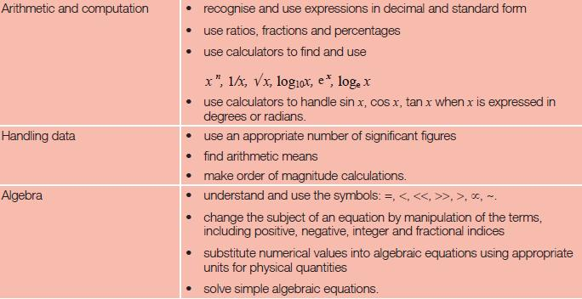

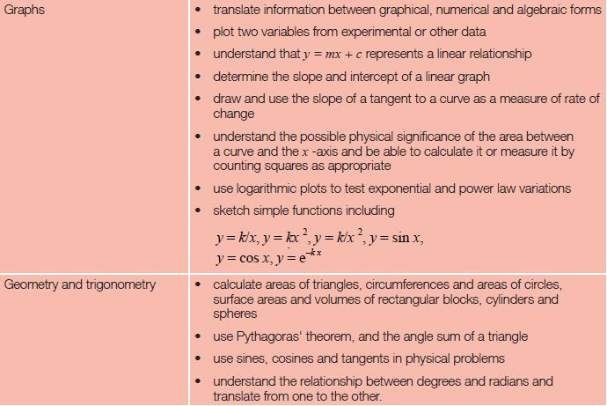

Appendix 6: Data and Formulae

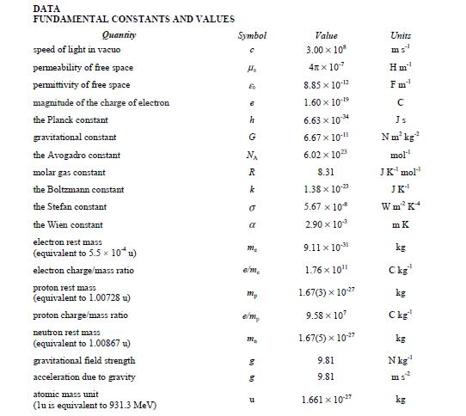

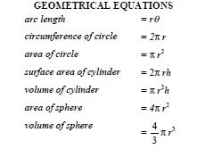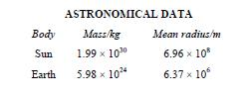

Appendix 6: AS Formulae

Appendix 6: A2 Formulae

Appendix 6: A2 OPTIONS: Data and Formulae

Appendix 7: Glossary of terms related to measurements

The AQA team of physics GCE examiners has produced the following list of definitions for use with AQA GCE Physics specifications and examinations.

Accepted value
The accepted value of a measurement is the value of the most accurate
measurement available. It is sometimes referred to as the .true. value.
Accuracy
Accuracy is a measure of confidence in an accurate measurement, often
expressed as an upper and lower limit of the measurement based on the
uncertainty in the measurement (e.g. g = 9.8 ± 0.3 m s-2).
Accurate measurements

A measurement which can be described as accurate is one that has been
obtained using accurately calibrated instruments correctly and where no
systematic errors arise.
Dependent variable
Dependent variables are those variable physical quantities whose values
change as a result of a change of value of another variable quantity. The
dependent variable is usually plotted on the vertical or y-axis of a graph.
Error
The difference between a measurement and its accepted value.
Often a misnomer suggesting that a mistake was made in taking a
reading.
Independent variable
Independent variables are those variable physical quantities whose
values are controlled or selected by the experimenter. Changing the
value of an independent variable usually results in a change of value of a
dependent variable. The independent variable is usually plotted on the
horizontal or x-axis of a graph.
Linearity
This is a design feature of many instruments and it means that the
readings are directly proportional to the magnitude of the variable being
measured. The scale of a moving coil meter is linear if it has evenly spaced
graduations on its scale each representing equal increases in current.
Mean value The mean value of a set of readings is calculated by adding the readings together and dividing by the number of readings.

Appendix 8: SI Base Units

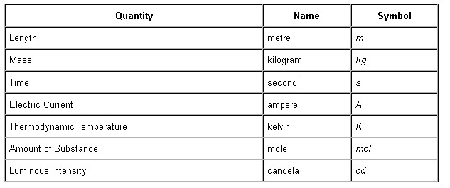

Appendix 9 : Derived Units

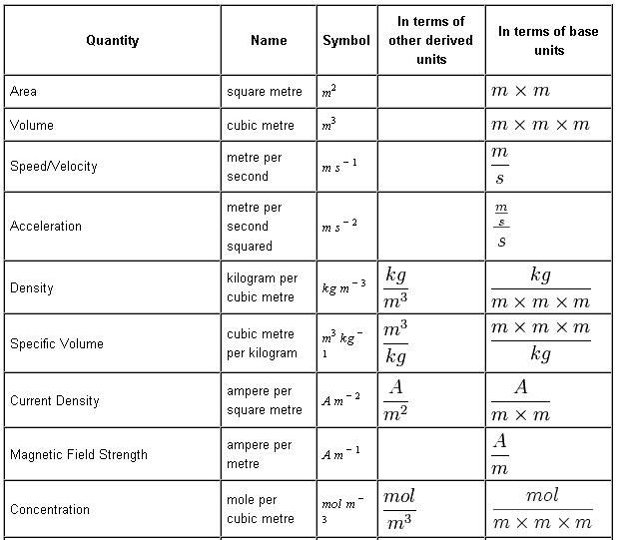
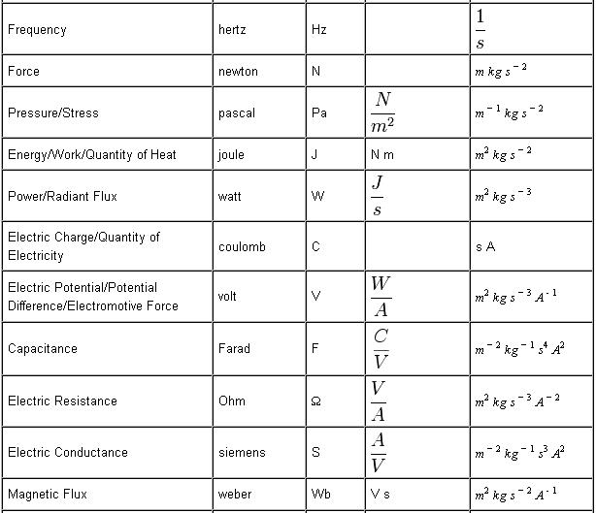

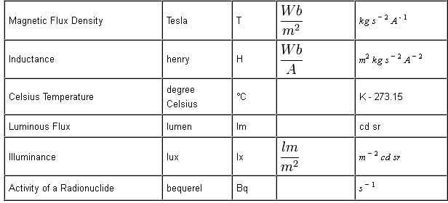

Appendix 10 : Prefixes and the Greek Alphabet

